Growth vs. light-capture in PhycoCyanin and PhycoErythrin-rich picocyanobacteria, across photic regimes and growth phases Long, low & slow; or high, short & fast; growth yields of light and photoperiods in PhycoCyanin and PhycoErythrin-rich picocyanobacteria

Sylwia Śliwińska-Wilczewska1,2, Marta Konik3,4, Mireille Savoie1, Anabella Aguilera5, Naaman Omar1, and Douglas A. Campbell1,✉

1 Department of Biology, Mount Allison University, 53 York St., Sackville NB, Canada, E4L 1C9  
2 Institute of Oceanography, University of Gdansk, 46 Pilsudskiego St, P81-378, Gdynia, Poland  
3 Department of Geography, University of Victoria, Victoria, BC V8P 5C2, Canada  
4 Institute of Oceanology, Polish Academy of Sciences, 81-712 Sopot, Poland  
5 Sweden

✉ Correspondence: [Douglas A. Campbell <[dcampbel@mta.ca](mailto:dcampbel@mta.ca)>](mailto:dcampbel@mta.ca)

# Abstract

The genus *Synechococcus* occurs in tropical, subtropical, temperate and arctic zones, with long-term scenarios forecasting range expansions of this picocyanobacteria into new photic regimes. We found that *Synechococcus* sp. showed photoperiod and light level-specific response, even if the cumulative diel photon dose (µmol photons m−2d−1) remains the same or similar. The most favorable growth conditions for both PC-rich and PE-rich strains were under low light (< 300 µmol photons m−2s−1) and the longest photoperiod (24 h), even though the cumulative diel PUR dose was equivalent to conditions where the light intensity was higher and the photoperiod was shorter. Under optimal conditions, PE-rich *Synechococcus* sp. achieved a chlorophyll specific exponential growth rate (µ) of 4.5 d−1 (3.7 h doubling time), which is the highest value recorded for cyanobacteria. Light capture efficacy to cumulative diel PAR, depending upon photoperiod and peak PAR, varied across the strains and phase of growth. PE-rich strains in the exponential phase of growth demonstrated high ability to modulate light capacity whereas PC-rich strains almost fixed PUR/PAR ratio. We find, for the first time, that PC-rich and PE-rich picocyanobacteria show consistent patterns of effective absorption cross section for PSII photochemistry (PSII′; nm2 quanta−1), versus increasing cumulative diel PAR doses. PE-rich strains remained at the higher PSII′ level than the PC-rich strains even as cumulative diel PAR increased. The PSII′ excited through phycobilisome absorbance at 590 nm were positively correlated with phycobiliprotein to Chl *a* ratio however, in the exponential growth phase, high variability was observed, likely related to regulatory control of PSII′ beyond pigment composition. Here, for the first time, we calibrated the *JV*PSII estimator to absolute rates of electron transport using parallel measures of oxygen evolution (µmolO2 L−1 s−1), captured simultaneously to the Fast Repetition Rate fluorometry (FRRf) measures. Based on these calculations, we found that µ, within each strain, show fairly consistent saturating responses to increasing cumulative diel PSII electron flux (*JV*PSII; µmol e− µmol Chl *a*−1 d−1). This work helps explain the differential seasonal prevalence of PC-rich and PE-rich *Synechococcus* sp., in terms of the growth yields and light-capture in different photic regimes.

*Keywords:* Cumulative diel photon dose, Light-capture, PAR, Photic regime, Phase of growth, Photoperiod, Picocyanobacteria, PUR

# Introduction

The photic regime, comprised of Photosynthetically Active Radiation (PAR), spectral quality, and photoperiod, is a pivotal influence on the growth and productivity of phytoplankton within aquatic ecosystems. PAR refers to the spectral range of solar radiation, approximately 400-700 nm, that is capable of driving photosynthesis. The availability and distribution of PAR in aquatic ecosystems is influenced by cloud cover, water depth, and light attenuation due to water turbidity and suspended particles, including phytoplankton cells (Kirk 1983; Field et al. 1998; Torremorell et al. 2009). Photosynthetically Usable Radiation (PUR), in turn is the fraction of PAR that can be absorbed for photosynthesis by pigments present in a given cyanobacteria or algae (Morel 1978). PUR thus depends upon the interaction of PAR, and the phytoplankter genomic expression of light capture capacity (Moejes et al. 2017; Grébert et al. 2018). Cyanobacteria also respond to changes in photoperiod, which serves as a key environmental cue for their metabolic activities and life cycle events (Alberte et al. 1980; Huisman et al. 2002; LaRoche and Robicheau 2022). The duration of light exposure within a day regulates physiological processes, including photosynthesis, growth, reproduction, and nutrient assimilation in cyanobacteria. Thus, in polar regions, characterized by prolonged periods of wintertime darkness and continuous daylight during summer, cyanobacteria encounter unique challenges. Light is the primary limiting factor for biomass production in winter, suppressing cyanobacteria growth and metabolic activity, whereas the extended daylight in summer boosts photosynthetic activity (Arrigo 2014). In temperate regions, seasonal variation in light-limitation is less pronounced, but cyanobacteria are still influenced by daily and seasonal fluctuations, with a contrast between more favorable conditions for cyanobacteria growth in spring and summer, compared to fall and winter (Huisman et al. 2002; Holtrop et al. 2021). In the tropics, daylight remains nearly constant throughout the year (Behrenfeld et al. 2006), and cyanobacteria productivity is rather controlled by nutrients resupply into the euphotic zone (Li et al. 2015; Hutchins and Boyd 2016), and mortality through viral lysis (Ortmann et al. 2002) and zooplankton grazing (Christaki et al. 1999).

*Synechococcus*, a diverse genus of picocyanobacteria, exhibits a distribution spanning diverse geographical regions (Flombaum et al. 2013), with strains demonstrating a remarkable range of adaptations to environmental conditions. *Synechococcus* capacity to thrive across diverse marine and freshwater habitats positions it as a pivotal agent in energy and nutrient transfer within food webs and serves as a link connecting the microbial loop with higher trophic levels, offering direct sustenance to grazers, including zooplankton and small fish (Li 1995). As one of the two dominant picocyanobacterial genera in oceanic waters, *Synechococcus* contribute significantly to light attenuation and light availability for other photosynthetic marine organisms, thereby influencing ocean colour and allowing satellite detection of *Synechococcus*-rich communities (Bracher et al. 2017; Xi et al. 2020). General relations among optical absorption spectra and pigment compositions have been used to determine diagnostic pigment indices of major phytoplankton functional types (Vidussi et al. 2001; Fishwick et al. 2006; Hirata et al. 2011). Modeling suggests that *Synechococcus* abundance and ranges will increase due to climate warming (Flombaum et al. 2013). The projected changes may vary geographically and may include shifts in the spatial distribution of the main picocyanobacteria, as well as changes in the proportions among *Synechococcus* sp. lineages (Six et al. 2021), potentially pushing lineages into new photic regimes. *Synechococcus* exhibits significant phenotypic diversity across lineages, encompassing strains rich in PhycoErythrin (PE-rich) or PhycoCyanin (PC-rich) (Haverkamp et al. 2009; Aguilera et al. 2023). These phycobilin pigment-proteins are pivotal for light absorption during photosynthesis and confer distinctive colours to the picocyanobacteria. The disparate light preferences between PC-rich and PE-rich *Synechococcus* sp. strains influence their ecological niches. PC-rich strains thrive in environments with elevated light levels, such as surface waters and coastal regions. PE-rich strains exhibit adaptation to lower-light conditions, primarily inhabiting the deeper layers of the water column. PC-rich and PE-rich *Synechococcus* sp. strains thus predominantly occupy complementary habitats (Six et al. 2007; Haverkamp et al. 2009; Six et al. 2021), although differential responses of *Synechococcus* lineages to photoperiod, have not been studied in detail, except thermophilic PC-rich *Synechococcus* PCC 6715 (Klepacz-Smółka et al. 2020).

Cyanobacteria growth includes lag, exponential growth, stationary, and death phases (Reynolds 2006). During the lag phase, cyanobacteria acclimate to the environment and prepare for active growth by synthesizing essential cellular components. Exponential growth phase is marked by cell division and biomass accumulation, fueled by nutrient and light availability. If growth is limited by declining nutrients, by light, or by accumulation of inhibitory factors, algae enter stationary phase, characterized by a balance between cell division and death, leading to a plateau in population. The death phase occurs when cyanobacteria cell death outruns division, leading to net decomposition, contributing to nutrient recycling in aquatic ecosystems (Reynolds 2006). Moreover, Schuurmans et al. (2017) proposed an additional phase which occurs between exponential and stationary phase of picocyanobacteria growth. This growth phase is often omitted in physiological studies. Here, we examined the physiological response of PC-rich and PE-rich *Synechococcus* sp. also in this phase, which we called the pre-stationary phase of growth. Since cell death may also release toxins into the environment, understanding the temporal progression of growth phases is thus essential for predicting cyanobacterial activity in a habitat, and their impact on ecosystem dynamics over time.

Picocyanobacteria are the most abundant phytoplankters in aquatic ecosystems and are crucial to the optical properties of ocean water, influencing its colour and transparency. Photic regimes and growth phases of PC-rich and PE-rich *Synechococcus* sp. may drive spatial and temporal variability of picocyanobacteria biomass and community lineage composition within current and potential future aquatic habitats, relating to varying metabolic costs between different physiological strategies for growth. Therefore, our aim was to determine whether photic regimes and growth phases differentially affect growth and light-capture, between representative PC-rich and PE-rich *Synechococcus* sp.

# Material and Methods

## Culture condition and experimental setup

Two non-axenic PhycoCyanin(PC)-rich (CCBA_056 or CCBA_077) strains and two PhycoErythrin(PE)-rich (CCBA_048 or CCBA_127) strains of *Synechococcus* belonging to different clades were obtained from the Culture Collection of Baltic Algae (CCBA; <https://ccba.ug.edu.pl/pages/en/home.php>). Pre-cultures of picocyanobacteria strains were kept in Tissue Culture Flasks (VWR International, Cat. No. 10062-872, PA, USA) and were transferred to fresh f/2 media (Guillard 1975) at salinity of 8 PSU (which corresponds to their natural habitat) every two weeks, under a photoperiod of 12 h and Photosynthetically Active Radiation (PAR) of 10 µmol photons m−2s−1 supplied from cool white fluorescent tubes, at 22℃.

Cultures of each strain were grown in 8 x 80 mL round bottom cylindrical glass tubes in a Multi-Cultivator MC 1000-OD (Photon Systems Instruments, Drásov, Czech Republic). Each culture tube contained 75 mL of f/2 medium inoculated with 5 mL of growing pre-culture, to achieve exponential growth from the beginning of the experiment, with little to no lag phase upon inoculation. Culture tubes were inoculated in the afternoon while the photoregime of a sinuisoidal photoperiod commenced the following morning such that peak PAR occurred at noon each day.

Cultures grew at 22℃, with photoperiods of 8, 12, 16, or 24 h, with peak PAR of 30, 90, 180, 300, 600, or 900 µmol photons m−2s−1 supplied from white LED lamps, independently to each culture tube. To approximate diel cycles, the photoperiods of 8 – 16 h were applied in a sinuisoidal shape, while the 24-hour photoperiod was applied continuously in a square shape. The area under the sinuisoidal curve is 1/2 the area under a square of equal width, therefore at equivalent peak PAR the 24 h square photoperiod cultures received 4 times the diel photon doses of the 12 h sinuisoidal photoperiod cultures.

Culture tubes were closed with a silicone inert silicone stopper perforated by an aeration input tube extending to the bottom of the culture tube, and a pressure outlet tube. Aeration with a total air flow rate of around ~ 140 mL min−1 tube−1 ensured mixing and provided sufficient air/CO2 supply to cultures through the entire culture volume. The pH of tested cultures did not fluctuate fiercely during the experiment and remained at approximately 8 – 9. Light, temperature, optical density, and aeration gas of the Multi-Cultivator system were monitored and controlled via the Photobioreactor Control Software (Photon Systems Instruments, Drásov, Czech Republic).

## Genomic analyses

Phylogenetic tree of tested PC-rich and PE-rich strains is presented in Fig. 1S (Supplementary materials).

## Growth curves and chlorophyll specific exponential growth rates

Picocyanobacterial growth was monitored every 5 minutes by automatically recording OD680, OD720, and ΔOD (ΔOD = OD680 – OD720) for 14 days, independently for each culture tube. The exceptions were experiments conducted with a photoperiod of 24 h and light of 600 or 900 µmol photons m−2s−1, which lasted 7 days (Fig S2-S4 in Supplementary materials). The chlorophyll specific exponential growth rates (µ) were determined by fitting logistic growth curves using a modified Levenberg-Marquardt fitting algorithm (Elzhov et al. 2023) to plots of the chlorophyll *a* proxy of ΔOD vs. elapsed time for each combination of strain, photoperiod, and peak PAR (Fig. S5 in Supplementary materials).

A Generalized Additive Model (GAM) (Wood 2017) was applied to the relation of chlorophyll specific growth rate (µ; d−1) to 4 photoperiods (8 – 24 h) and 6 peak PAR (30 – 900 µmol photons m−2s−1) levels, for two PC-rich cultures (056, 077) and two PE-rich cultures (048, 127) of *Synechococcus* sp. originating from the Baltic Sea. The R package *mgcv* (Wood 2023) was used to model the growth rate with smoothing terms and indicate the 10%, 50%, and 90% quantiles for growth rate across the levels of photoperiod and peak PAR.

The 1st derivative of OD680 taken over 1 h increments was computed using xts: eXtensible Time Series (Ryan et al. 2024) and signal: Signal Processing (Ligges et al. 2024) R packages. The time when the cultures reached their maximum absolute hourly growth (tMaxAHG) of the 1st derivative of OD680 was taken as the time of transition from exponential to pre-stationary growth phases (Fig. 1).



Figure 1: **Example of a growth curve (tracked as OD720, OD680, or ΔOD; red solid lines, left y-axis) of PE-rich culture of *Synechococcus* sp. (048) vs. elapsed time (d, x-axis).** 1st derivative of OD680 taken over 1 h increments (black solid line, right y-axis); solid blue line shows logistic fits of chlorophyll proxy OD680 – OD720 (ΔOD) vs. elapsed time. The vertical red dot dash line represents the time when the culture reached the maximum of the 1st derivative of OD680, or maximum absolute hourly growth (tMaxAHG), taken as the time of transition from exponential to pre-stationary growth phases.

## Determining the number of cells

The number of picocyanobacterial cells (cell mL−1) was measured using an ImageXpress Pico Digital microscope equipped with CMOS camera and LED+ image autofocus (ImageXpress Pico Automated Cell Imaging System, Molecular Devices, LLC., CA, USA). Culture samples were preserved with 4% glutaraldehyde and kept at -80°C until the measurements. Samples (V = 10 µL) were transferred to Tissue Culture (TC)-treated surface, flat bottom black 96-well plates (Corning® Falcon® Microplate, MilliporeSigma, Merck, Darmstadt, Germany) containing 200 µL of f/2 media and centrifuged using a Beckman J-20 centrifuge with a swing bucket JS-4.3 rotor at 4500 rpm (Beckman Coulter, Brea, California, United States). Cells were imaged with the Cy5 channels (Excitation: 630/40 nm; Emission: 695/45 nm; Dichroic: 655 nm) using selectable confocal geometries, which allowed us to distinguish cyanobacterial cells from any co-occurring heterotrophic bacteria, and counted using a 63x objective in fluorescence imaging modes. Quantitative analysis on images acquired from automated microscopy obtained from 96-well microplates was performed using CellReporterXpress Image Acquisition and Analysis Software (Wlodkowic et al. 2022). The actual cell number was calculated based on the dilution factor and selected area count in each well.

## Whole-cell absorbance spectra measurements

Absorbance measurements on intact cells in suspension were conducted in an integrating cavity upgrade spectrophotometer (CLARiTY 17 UV/Vis/NIR, On-Line Instrument Systems, Inc., Bogart, GA, USA) according to Blake and Griff (2012) with modifications. 8 mL of f/2 medium were added to both the sample and reference observation cavities of the spectrophotometer. After recording a baseline from 375 to 710 nm, 1 mL was withdrawn from the sample cavity and replaced with 1 mL of picocyanobacteria cell suspension. The pathlength corrected absorbance per cm was performed by determining the Jávorfi coefficients (Jávorfi et al. 2006) as described in the equipment manual.

## Estimating Photosynthetically Usable Radiation (PUR)

Using whole-cell absorbance spectra of *Synechococcus* sp. cultures (Fig. 2), we estimated Photosynthetically Usable Radiation (PUR; µE = µmol photons m−2s−1) according to (Morel 1978). We normalized the obtained whole-cell Absorbances (A) and the Emission spectra of the white LED lamps (Em) from 400 nm to 700 nm to a reference wavelength of 440 nm. PUR is then the ratio of the sum of Absorbance Normalized to 440 nm (NormA440) multiplied by the sum of Emission spectra Normalized to 440 nm (NormEm440) to the sum of the Emission spectra Normalized to 440 nm (NormEm440), multiplied by the PAR (Eq. (1)).

$$PUR \left(µE\right)=\frac{∑\left(NormA_{440} × NormEm_{440}\right)}{∑\left(NormEm_{440}\right)} × PAR \left(µE\right) \left(1\right)$$



Figure 2: **Whole-cell absorbance spectra of PC-rich (solid green lines) or PE-rich (dashed red lines) cultures of *Synechococcus* sp.** Representative absorbance spectra, normalized to 440 nm (NormA440), were measured from the exponential or pre-stationary phases of growth, together with emission spectra of the white LED lamp used for PAR, normalized to emission at 440 nm (NormEm440, light gray area), in this example PAR was 300 µmol photons m−2s−1. Estimated Photosynthetically Usable Radiation (PUR) is shown as a darker green area for the PC-rich strain and a darker red area for the PE-rich strain, with PUR given for each culture (µE = µmol photons m−2s−1). Peaks characteristic of known pigments are labeled; Chl *a*, chlorophyll *a*; PC, phycocyanin; PE, phycoerythrin; PUB, phycourobilin; Car, carotenoids.

## Estimating cumulative diel PAR and PUR

Based on the length and shape of the photoperiod (sinuisoidal wave for photoperiods of 8 – 16 h; square for photoperiod of 24 h) and the peak PAR (µE = µmol photons m−2s−1), we estimated the value of the cumulative diel PAR (µmol photons m−2d−1). For sinuisoidal photoperiods we used Eq. (2); for the continuous 24 h photoperiod we used Eq. (3).

$$\begin{matrix}Cumulative diel PAR \left(µmol photons m^{−2} d^{−1}\right)= \\ \frac{PAR \left(µE\right)×60 \left(s min^{−1}\right)×60 \left(min h^{−1}\right)×photoperiod \left(h d^{−1}\right)}{2} \left(2\right)\end{matrix}$$

$$\begin{matrix}Cumulative diel PAR \left(µmol photons m^{−2} d^{−1}\right)= \\ PAR \left(µE\right)×60 \left(s min^{−1}\right)×60 \left(min h^{−1}\right)×photoperiod \left(h d^{−1}\right) \left(3\right)\end{matrix}$$

Cumulative diel PUR was estimated similarly after estimation of peak PUR from peak PAR.

## Pigment content analysis

The chlorophyll *a* (Chl *a*) content (µg mL−1) was measured using Trilogy Laboratory Fluorometer (Turner Designs, Inc., CA, USA) equipped with Chlorophyll In-Vivo Module, previously calibrated using 20 mL ampoules with known Chl *a* concentrations in 3:2 90% acetone/DMSO solution. Quantitative analysis of Chl *a* was obtained after adding 50 µL of culture and 2 mL of a 90% acetone/DMSO solution in a 3/2 ratio (Schraga and Cloern 2017).

We also estimated the pigment content (µg mL−1): chlorophyll *a* (Chl *a*), carotenoids (Car), phycoerythrin (PE), phycocyanin (PC), and allophycocyanin (APC) in *Synechococcus* sp. cultures over time using previously determined linear correlations between pigment content obtained by extraction technique (Strickland and Parsons 1972; Bennett and Bogorad 1973) and absorbance values of individual pigment peaks (Car; 480, PE; 565, PC; 620, APC; 650, and Chl *a*; 665 nm) obtained from the whole-cell absorbance spectra using integrating cavity upgrade spectrophotometer (CLARiTY 17 UV/Vis/NIR, On-Line Instrument Systems, Inc., Bogart, GA, USA) (Tab. S1, Supplementary materials). The sum of phycobilins (PE, PC, APC protein; Phycobiliprotein) to Chl *a* ratio (µg/µg) for individual strains was also calculated.

## Estimating effective absorption cross section of PSII, and PSII electron flux

We harvested 2 mL of cultures for photophysiological characterizations repeatedly across the growth trajectories. We used Fast Repetition Rate fluorometry (Kolber et al. 1998) (FRRf, Solisense, USA), with a lab built temperature control jacket, to apply series of flashlets to drive induction/relaxation trajectories, and used the onboard Solisense LIFT software to fit an induction/relaxation model (Falkowski and Kolber 1993; Kolber et al. 1998). From the model fits we took the initial fluorescence before induction (*F*O, *F*O′, or *F*S); the maximum fluorescence (*F*M or *F*M′) once Photosystem II (PSII) was driven to closure; and the effective absorption cross section for PSII photochemistry (σPSII or σPSII′; nm2 quanta−1) (Tortell et al. 2021). We used a double tap protocol (Xu et al. 2017), where FRRf induction/relaxation trajectories were collected during a rapid light curve sequence increasing in steps of 10 s at 0, 20, 40, 80, 160, and 320 µmol photons m−2s−1 PAR, delivered from LED emitters centred at 445, preferentially exciting chlorophyll, or 590 nm, preferentially exciting phycobiliproteins. Flash Power for 445 nm excitation was 60000 µmol photons m−2s−1 PAR, while for 590 nm excitation power was 14000 µmol photons m−2s−1, calibrated using a quantum sensor (LI-250, LI-COR, Inc.). We applied 1 s darkness between sequential light steps, to allow re-opening of PSII. FRRf excitation flashlets were applied at the same wavebands, 445 or 590 nm, as the actinic light steps.

We calculated (Eq. (4)) a fluorescence estimator for volumetric electron transport, *JV*PSII, (e− L−1 s−1) under both 445 and 590 nm excitation bands (Oxborough et al. 2012; Boatman et al. 2019; Tortell et al. 2021).

$$JV_{PSII}=\frac{σ_{PSII}′×qP×I×F_{O}}{σ_{PSII}} \left(4\right)$$

where PSII′ is effective absorption cross section for PSII photochemistry under the relevant actinic PAR step (nm2 quanta−1); qP is an estimate of the fraction of PSII open for photochemistry estimated according to Oxborough and Baker (1997); I is the applied PAR (µmol photons m−2s−1); *F*O is the minimum fluorescence from a given sample and excitation bandwidth (relative fluorescence) and PSII is the maximum effective absorption cross section for PSII photochemistry from a given sample and excitation bandwidth (nm2 quanta−1). We compared several other algorithms for *JV*PSII (Tortell et al. 2021) and found similar results.

We calibrated the *JV*PSII estimator to absolute rates of electron transport (Eq. (4)) using parallel measures of oxygen evolution (µmolO2 L−1 s−1), captured simultaneously to the FRRf measures, below light saturation, using a FireSting robust oxygen probe (PyroScience, Germany) inserted in the cuvette for select RLC runs (Fig. 3). For the blue LED (Ex445nm) excitation we used a calibration slope of 106941, while for orange LED (Ex590nm) excitation we used a calibration slope of 251096.

$$JV_{PSII}\left(e^{−} L^{−1} s^{−1}\right)=\frac{Uncalibrated JV_{PSII}\left(e^{−} L^{−1} s^{−1}\right)}{Calibration slope} \left(4\right)$$



Figure 3: **Single turnover (ST) fluorescence induction by Fast Repetition Rate fluorometry (FRRf).** Top panel (A) shows examples of fluorescence yield vs. elapsed time (µs) for PE-rich culture of *Synechococcus* sp. (048) in the dark (dark-relaxed; 0 µmol photons m−2s−1) and under actinic PAR (in this example 80 µmol photons m−2s−1) using blue LED (Ex445nm; open blue circles) or orange (Ex590nm; open orange diamonds) excitation. The ST technique delivers a series of flashlets for non-intrusive, repeated monitoring of chlorophyll fluorescence parameters (including *F*O, *F*′, *F*M, *F*M′, τ1-τ3, τ1′-τ3′, σPSII, and σPSII′). Panel B shows linear regressions of uncalibrated PSII electron flux (*JV*PSII) vs. e− L−1 s−1 derived from simultaneously measured oxygen evolution Light Response Curves (LRC) under blue LED (Ex445nm; open blue circles) or orange (Ex590nm; open orange diamonds) excitation. Panel C shows a Rapid Light Curve (RLC), fit with a three parameter model (Harrison and Platt 1986), for PSII electron flux (*JV*PSII; µmol e− µmol Chl *a*−1 s−1) vs. actinic PAR measured under blue LED (Ex445nm; open blue circles) or orange (Ex590nm; open orange diamonds) excitation.

## Statistical analysis

Analysis of results was conducted using R version 4.3.0 (R Core Team 2019) running under RStudio (Team 2015). To determine significant differences in studied experiments the “stats” v. 3.6.2 R standard package was used. This package provides basic statistical functions, including the *lm()* function for linear regression, *aov()* function for ANOVA, and *t.test()* function for *t*-test. The *SSasymp(*) function (Self-Starting Nls Asymptotic Regression Model) was used to perform a single phase exponential decay fit model and to estimate exponential decay parameters (y0, the starting value; yf, the value at infinite x axis; λ, exponential decay constant) (Serway et al. 2004). We also used *nlsLM()* function (Elzhov et al. 2023) to perform a three parameter model ($α$, initial slope of curve; $β$, reflecting the photoinhibition process; Pmax, the maximum rate of growth curve) proposed by Harrison and Platt (1986).

We performed three-way factorial ANOVA to determine whether peak PAR, photoperiod, strain, and their interactions, significantly influence the chlorophyll specific exponential growth rate (µ; d−1), estimated from logistic fits of chlorophyll proxy OD680 – OD720 vs. cumulative diel PUR (Table S2).

To examine statistical differences between fits of light responses, we performed one-way ANOVA of the three parameter model (Harrison and Platt 1986) fit to pooled data for each taxa, and fit separately to each different photoperiods (8, 12, 16, or 24); or fit separately to different peak PAR (30, 90, 180, 300, 600 together with 900). These comparisons were run for chlorophyll specific exponential growth rate vs. cumulative diel PUR (Table S3, S4); vs. cumulative diel PAR (Table S5, S6) or vs. PSII electron flux (*JV*PSII; µmol e− µmol Chl *a*−1 d−1; Table S7, S8). One-way ANOVA was also used to examine statistical differences between single phase exponential decay fits of pooled data across different strains for a given phase of growth and across different phase of growth for a given strain for PUR/PAR ratio (Table S9); Phycobiliprotein to Chl *a* ratio (Table S10); or effective absorption cross section of PSII (PSII′; nm2 quanta−1) measured under diel peak PAR growth light under Ex590nm (orange) excitation in relation to the cumulative diel PAR (µmol photons m−2d−1) (Table S11).

We used *t*-tests of linear fits to compare pooled data across different strains for a given phase of growth, and across different phases of growth, for a given strain, for effective absorption cross section of PSII (PSIIʹ; nm2 quanta−1) measured under diel peak PAR growth light under Ex445nm (blue) excitation vs. the cumulative diel PAR (µmol photons m−2d−1; Table S12); or vs. the Phycobiliprotein to Chl *a* ratio (Table S13). The same *t*-test analyses were performed for effective absorption cross section of PSII (PSII′ or PSII; nm2 quanta−1) measured under Ex590nm (orange) excitation vs. the Phycobiliprotein to Chl *a* ratio (Table S14, S15).

Statistical differences for all analyses were determined at significance level $α$ = 0.05. The manuscript was prepared as a Rmarkdown document (Handel 2020) with figures plotted using the ggplot2 (Wickham 2016) and the patchwork (Pedersen 2024) packages. For reproducibility all code, data and metadata is available at GitHub repository (<https://github.com/FundyPhytoPhys/BalticPhotoperiod>).

# Results

## Changes in chlorophyll-specific exponential growth rate

We used logistic curve fits (Fig. S5) to determine chlorophyll-specific exponential growth rates (μ; d−1), for two PhycoCyanin(PC)-rich cultures (056, 077) and two PhycoErythrin(PE)-rich cultures (048, 127) of *Synechococcus* sp. originating from the Baltic Sea grown at 30, 90, 180, 300, 600, or 900 peak PAR µmol photons m−2s−1 (µE); and photoperiods of 8, 12, 16, or 24 h. Three-way factorial ANOVA showed that peak PAR, photoperiod, strain, and their interactions, significantly affected μ (ANOVA, *p* < 0.05 for all; Table S2). All tested strains, except PE-rich_048, grew even under peak PAR 900 µmol photons m−2s−1 and 24 h photoperiod. The highest growth rate was recorded for *Synechococcus* sp. PE-rich_127 (μ = 4.5 d−1) and PC-rich_056 (μ = 3.4 d−1) at 180 µmol photons m−2s−1 peak PAR and photoperiod of 24 h.

The GAM model in Fig. 4 summarizes growth responses of PC-rich and PE-rich picocyanobacteria to peak PAR and photoperiod. PC-rich_056 *Synechococcus* sp. showed the highest growth rate under a photoperiod of 24 h, regardless of the prevailing peak PAR indicated by the contour line labeled 1.45 d−1 (representing the 90th percentile of achieved growth rate). On the other hand, the other tested PC-rich strain (077) showed the highest growth in the range of photoperiod 16-24 h and peak PAR between 300 – 700 µmol photons m−2s−1 indicated by the 1.81 d−1 contour line representing the 90th percentile of maximum achieved growth rate. Also, For both PC-rich strains, growth was the lowest in the 30 µmol photons m−2s−1 and photoperiod of 8 h. Note, the growth rate for PC-rich and PE-rich *Synechococcus* sp. was not consistent with the cumulative diel photon dose (µmol photons m−2d−1). Both PE-rich strains achieved fastest growth rates above peak PAR of ~300 µmol photons m−2s−1, and the longest photoperiod of 24 h, indicated by the 1.97 d−1 for PE-rich_048 and 2.34 d−1 for PE-rich_127 contour line representing the 90th percentile of maximum achieved growth rate. For these strains growth decreased with decreasing photoperiod and decreasing peak PAR. Moreover, PE-rich strains showed strong photoinhibition at peak PAR of 900 µmol photons m−2s−1 and photoperiod of 24 h.

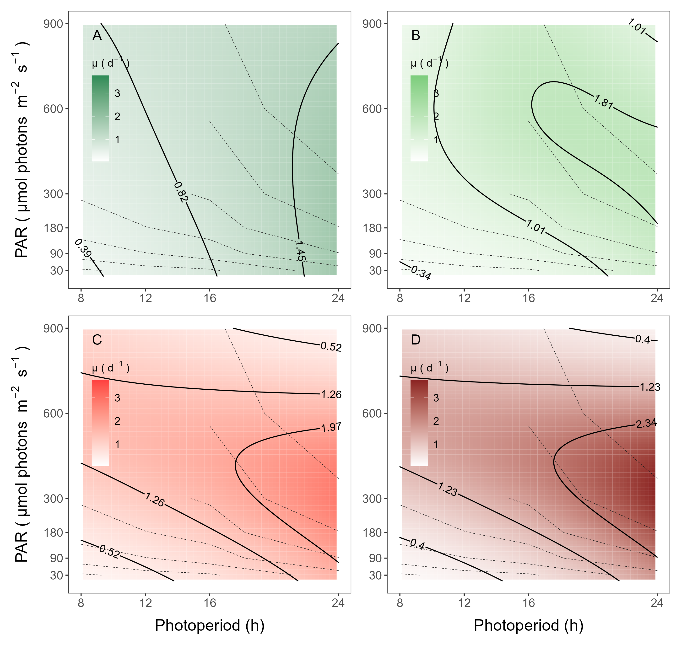

Figure 4: **A contour plot of a Generalized Additive Model (GAM) of chlorophyll specific growth rates (d−1)** for two PhycoCyanin(PC)-rich cultures (A; 056, B; 077) and two PhycoErythrin(PE)-rich cultures (C; 048, D; 127) of *Synechococcus* sp. originating from the Baltic Sea. Cultures were grown at 30, 90, 180, 300, 600, or 900 peak PAR µmol photons m−2s−1; and photoperiods of 8, 12, 16, or 24 h. Legends show colour gradients of growth rate (µ; d−1) from no growth (white) to 3.0 d−1 (dark green for PC-rich_056, light green for PC-rich_077, light red for PE-rich_048 or dark red for PE-rich_127 strains). Labeled contour lines indicate the 90%, 50%, and 10% quantiles for achieved growth rate. Dashed contour lines show isoclines of cumulative diel photon dose (µmol photons m−2d−1).

A three parameter light response model fit (Harrison and Platt 1986) of chlorophyll-specific exponential growth rates vs. cumulative diel PUR dose for two PC-rich and two PE-rich cultures of *Synechococcus* sp. showed significant differences between model fits of the pooled data vs. fits for different photoperiods (8, 12, 16, or 24 h; ANOVA, *p* < 0.05; Fig. 5, Table S3).

Strains also showed distinct growth rate responses to cumulative diel PUR, depending upon peak PAR (Fig. 6). Strains generally showed differential growth rate responses to cumulative diel PUR dose at different peak-PAR, that differ from a single light response model fit to the pooled data from a strain. Exceptions were observed in the strains PC-rich_077 and PE-rich_048 with the peak PAR of 600 or 900 µmol photons m−2s−1, which were not significantly different from the pooled data model (Table S4). A caveat to these findings is that cumulative diel photon dose is a product of photoperiod and PAR, so the highest levels of cumulative PUR dose are only achieved under the 600 or 900 µµmol photons m−2s−1.

Growth rate saturated under increasing cumulative diel PUR for all strains, however, the achieved estimates of µmax varied depending upon photoperiod and peak diel PAR. Growth rates vs. cumulative diel PAR relationships, estimated for exponential phase cultures, followed similar patterns (Fig. S6, S7 and Table S5, S6 in Supplemental material).

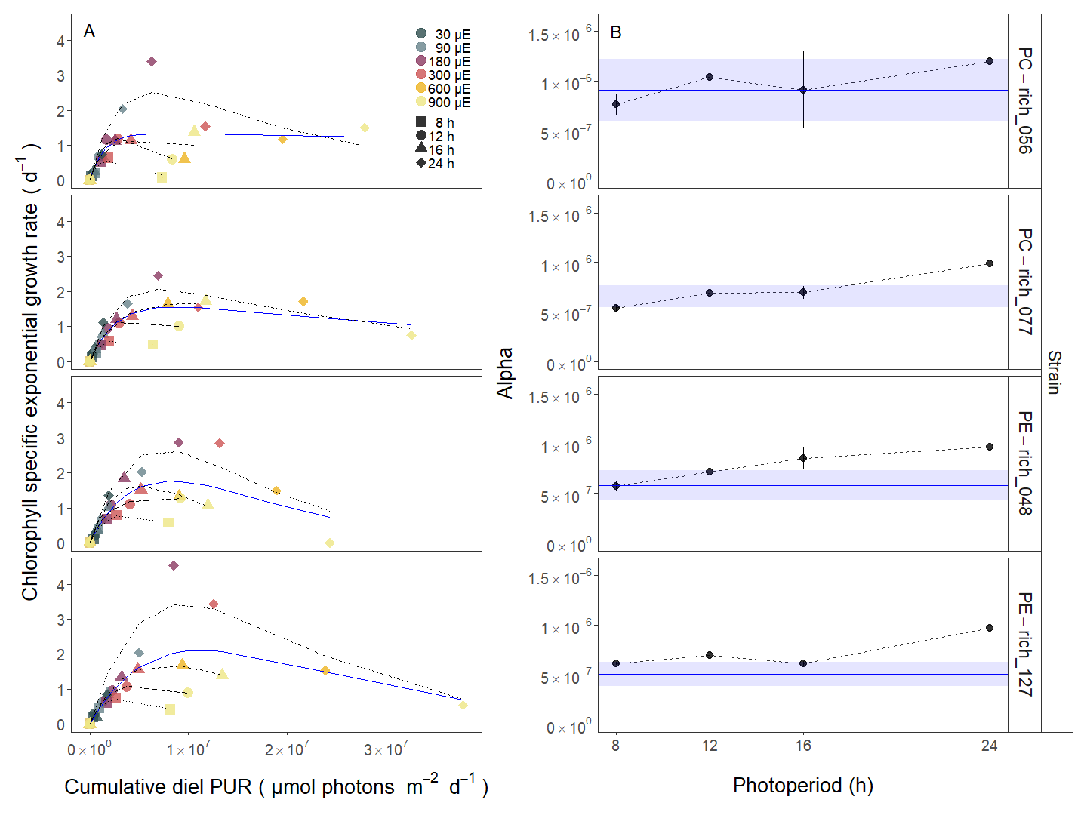

Figure 5: **Chlorophyll specific exponential growth rates (d−1) vs. cumulative diel Photosynthetically Usable Radiation (PUR, µmol photons m−2d−1).** **A.** Growth rates (+/- SE falling within symbols) were estimated from logistic fits of chlorophyll proxy OD680 – OD720 (ΔOD) vs. elapsed time (Fig. 1, Fig. S5), for two PhycoCyanin(PC)-rich cultures (056, 077) and two PhycoErythrin(PE)-rich cultures (048, 127) of *Synechococcus* sp. originating from the Baltic Sea. Cultures were grown at 30 (dark gray), 90 (light gray), 180 (purple), 300 (red), 600 (orange), or 900 (yellow) peak PAR µmol photons m−2s−1 (µE); and photoperiods of 8 (square), 12 (circle), 16 (triangle), or 24 (diamond) h. Solid blue line shows a fit of the pooled growth rates for each strain, with a three parameter model (Harrison and Platt 1986). We also fit the same model separately for 8 (dotted line), 12 (long dash line), 16 (dashed line), or 24 (two dash line) h photoperiods, since for all strains they were each significantly different (ANOVA, *p* < 0.05) from the fit of pooled data. **B.** Alpha parameters of the initial rise of growth rate vs. cumulative diel Photosynthetically Usable Radiation, estimated from data pooled for each photoperiod (points (+/- SE) connected by dashed lines), and estimated for all data across photoperiods (horizontal line +/- SE), for each strain.

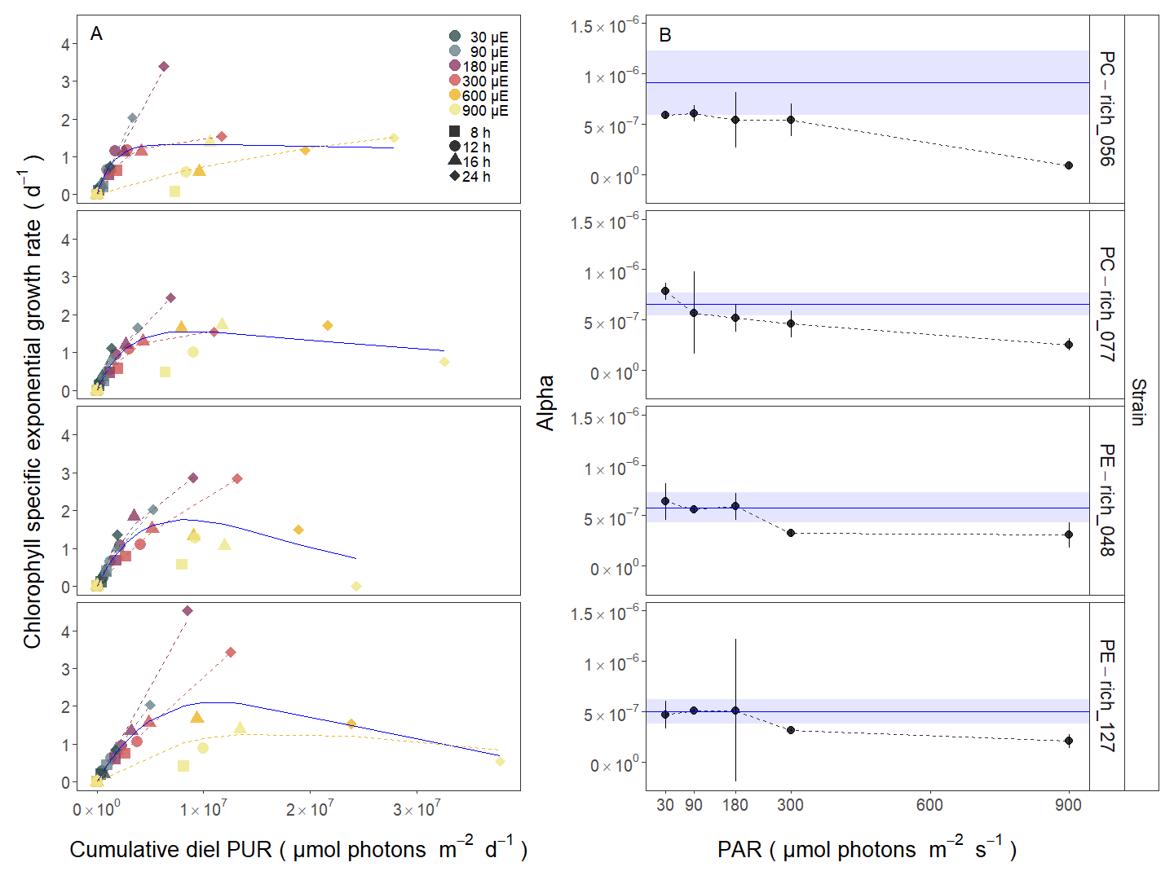

Figure 6: **Chlorophyll specific exponential growth rates (d−1) vs. cumulative diel Photosynthetically Usable Radiation (PUR, µmol photons m−2d−1).** **A.** Growth rates (+/- SE falling within symbols) were estimated from logistic fits of chlorophyll proxy OD680 – OD720 (ΔOD) vs. elapsed time (Fig. 1, Fig. S5), for two PhycoCyanin(PC)-rich cultures (056, 077) and two PhycoErythrin(PE)-rich cultures (048, 127) of *Synechococcus* sp. originating from the Baltic Sea. Cultures were grown at 30 (dark gray), 90 (light gray), 180 (purple), 300 (red), 600 (orange), or 900 (yellow) peak PAR µmol photons m−2s−1 (µE); and photoperiods of 8 (square), 12 (circle), 16 (triangle), or 24 (diamond) h. Solid blue line shows a fit of the pooled growth rates for each strain, with a three parameter model (Harrison and Platt, 1986). We also fit the same model separately for 30 (dark gray), 90 (light gray), 180 (purple), 300 (red), 600 together with 900 (orange) peak PAR µmol photons m−2s−1, only when they were each significantly different (ANOVA, *p* < 0.05) from the fit of pooled data.**B.** Alpha parameters of the initial rise of growth rate vs. cumulative diel Photosynthetically Usable Radiation, estimated from data pooled for each peak PAR (points (+/- SE) connected by dashed lines), and estimated for all data across all peak PAR, for each strain (horizontal line +/- SE).

## Decreasing PUR/PAR ratio with increasing cumulative diel PAR

The PUR/PAR ratio is an index of the efficacy of light capture for a culture under a given growth condition; showing the fraction of PAR that can be captured by the absorbance of the cells (Fig. 7). For the two PC-rich and, particularly, for the two PE-rich cultures of *Synechococcus* sp. PUR/PAR decayed exponentially with increasing cumulative diel PAR, pooling data across different combinations of photoperiod and peak PAR. Although all strains followed a similar trend, the single phase exponential decay model fit parameters varied significantly among strains, during their exponential phase of growth (ANOVA, *p* < 0.05), except the model fits from PE-rich_048 and PE-rich_127 (ANOVA, *p* > 0.05; Table S9). Moreover, the PUR/PAR ratio was higher in the PE-rich strains under low cumulative diel photon dose during their exponential phase of growth (y0 greater or equal to 0.9), but decayed towards a plateau close to the PC-rich strains as cumulative diel photon dose increases (yf = 0.5). Also, λ, describing exponential decay constant, for PE-rich strains was almost 2-fold higher compared to PC-rich picocyanobacteria. On the other hand, the single phase exponential decay model fits did not differ significantly among strains, during their pre-stationary phase of growth (ANOVA, *p* > 0.05; Table S9). During this phase, response of PUR/PAR to increasing cumulative diel PAR dampens and remains constant for all strains in the range yf = 0.4 – 0.5, except PE-rich_048. We also find that model fits from different phases of growth differed within a given strain, with the exception of PC-rich_056 (ANOVA; *p* < 0.05, Table S9). The same decaying trend was observed for Phycobiliprotein to Chl *a* ratio (µg/µg) across cumulative diel PAR (Fig. S8).



Figure 7: **Changes in PUR/PAR ratio vs. cumulative diel PAR (µmol photons m−2d−1).** PUR/PAR ratio was estimated for two PhycoCyanin(PC)-rich cultures (056, 077) and two PhycoErythrin(PE)-rich cultures (048, 127) of *Synechococcus* sp. originating from the Baltic Sea. Cultures were grown at 30 (dark gray), 90 (light gray), 180 (purple), 300 (red), 600 (orange), or 900 (yellow) peak PAR µmol photons m−2s−1 (µE); and photoperiods of 8 (square), 12 (circle), 16 (triangle), or 24 (diamond) h. Figure presents data (smaller symbols) and means (bigger symbols) from exponential or pre-stationary phase of growth. Blue solid line shows single phase exponential decay fit for data from each strain and growth phase, with fit parameters presented. Different lowercase letters indicate statistically significant differences between the fit models for different strains within a given phase of growth. Different uppercase letters indicate statistically significant differences between the fit models for different phases of growth within a given strain (ANOVA; *p* < 0.05).

## Decreasing effective absorption cross section of PSII with increasing cumulative diel PAR

We estimated the effective absorption cross section of PSII (PSIIʹ, nm2 quanta−1), measured under diel peak PAR growth light for each culture, vs. cumulative diel photon dose (µmol photons m−2d−1). PSIIʹ was estimated using FRRf induction curves using Ex590nm (orange) excitation, for two PC-rich (056, 077) and two PE-rich (048, 127) cultures of *Synechococcus* sp. grown at 30, 90, 180, 300, 600, or 900 peak PAR µmol photons m−2s−1 (µE); and photoperiods of 8, 12, 16, or 24 h (Fig. 8). The PSIIʹ measured under diel peak PAR growth light under Ex445nm (blue) excitation vs. cumulative diel photon dose is shown in Supplementary material (Fig. S9, Table S12).

All strains showed consistent patterns of sharp, exponential decay of effective absorption cross section for PSII photochemistry vs. cumulative diel photon doses, across different combinations of photoperiod and peak PAR. Although all strains showed this response pattern, the exponential decay fits differed significantly among two PC-rich strains and PE-rich_048 during their exponential phase of growth (ANOVA, *p* < 0.05; Table S11). PE-rich strains showed higher σPSIIʹ under low cumulative diel photon dose (y0 about 0.8 and yf about 4) than PC-rich strains however, decayed parameter λ remained at a similar level for all cultures. During pre-stationary phase this response dampens in the PC-rich strains but persists in the PE-rich strains (Table S11). PSIIʹ for the PE-rich strains during this phase of growth still remain higher (yf between 2.3 – 3.0) than the PC-rich strains (yf between 1.4 – 1.7) even as cumulative diel photon dose increases. Also, model fits from different phases of growth differed within a given strain, with the exception of PE-rich_048 (ANOVA; *p* < 0.05, Table S11).



Figure 8: **Effective absorption cross section of PSII** (σPSIIʹ; nm2 quanta−1) **measured under diel peak PAR growth light vs. cumulative diel PAR (µmol photons m−2d−1).** Effective absorption cross section of PSII (σPSIIʹ; nm2 quanta−1) was estimated using FRRf induction curves with excitation of phycobilisomes (Ex590nm, orange), for two PhycoCyanin(PC)-rich cultures (056, 077) and two PhycoErythrin(PE)-rich cultures (048, 127) of *Synechococcus* sp. originating from the Baltic Sea. Cultures were grown at 30 (dark gray), 90 (light gray), 180 (purple), 300 (red), 600 (orange), or 900 (yellow) peak PAR µmol photons m−2s−1 (µE); and photoperiods of 8 (square), 12 (circle), 16 (triangle), or 24 (diamond) h. Figure presents data (smaller symbols) and means (bigger symbols) from exponential or pre-stationary phase of growth. Blue solid line shows single phase exponential decay fit for data from each strain and growth phase. Different lowercase letters indicate statistically significant differences between the fit models for different strains within a given phase of growth. Different uppercase letters indicate statistically significant differences between the fit models for different phases of growth within a given strain (ANOVA; *p* < 0.05).

We also estimated the changes of effective absorption cross section of PSII (PSIIʹ; nm2 quanta−1) measured under diel peak PAR growth light with excitation of phycobilisomes (Ex590nm, orange) vs. Phycobiliprotein to Chl *a* ratio (µg/µg) for two PC-rich and two PE-rich cultures of Synechococcus sp. (Fig. 8). Moreover, changes in effective absorption cross section of PSII (PSII; nm2 quanta−1) measured in the dark with Ex590nm (orange) excitation vs. Phycobiliprotein to Chl *a* ratio (Fig. S8, Table S15) and PSIIʹ measured under diel peak PAR growth light under Ex445nm (blue) excitation vs. Phycobiliprotein to Chl *a* ratio (Fig. S10 and Table S13) are shown in Supplementary materials.

Effective absorption cross section of PSII (PSIIʹ; nm2 quanta−1), measured under diel peak PAR growth light with Ex590nm (orange) excitation, vary with Phycobiliprotein to Chl *a* ratio, for PC-rich_056, PC-rich_077, PE-rich_048, and PE-rich_127 cultures of *Synechococcus* sp. grown at 30, 90, 180, 300, 600, or 900 peak PAR µmol photons m−2s−1 (µE); and photoperiods of 8, 12, 16, or 24 h (Fig. 9). PSIIʹ excited through phycobilisome absorbance at Ex590nm shows consistent positive correlations with the Phycobiliprotein to Chl *a* ratio, although strains in exponential growth show significant scatter around this positive relation, likely related to regulatory control of PSIIʹ under different measurement PAR, beyond pigment composition. Under pre-stationary phase the relationship between PSIIʹ and Phycobiliprotein to Chl *a* ratio was more consistent, suggesting increased reliance upon compositional regulation to control light delivery to PSII, as opposed to shorter-term physiological regulation under changing light. The linear fits of PSIIʹ vs. Phycobiliprotein to Chl *a* ratio also vary significantly between PC-rich_077 and two PE-rich strains during their exponential phase of growth. During pre-stationary phase we noted significant differences between two PC-rich strains and PE-rich_048. Moreover, significant differences between the fit models for varying phases of growth were noted for PC-rich strains 056 and 077 (*t*-test; *p* < 0.05, Table S14).

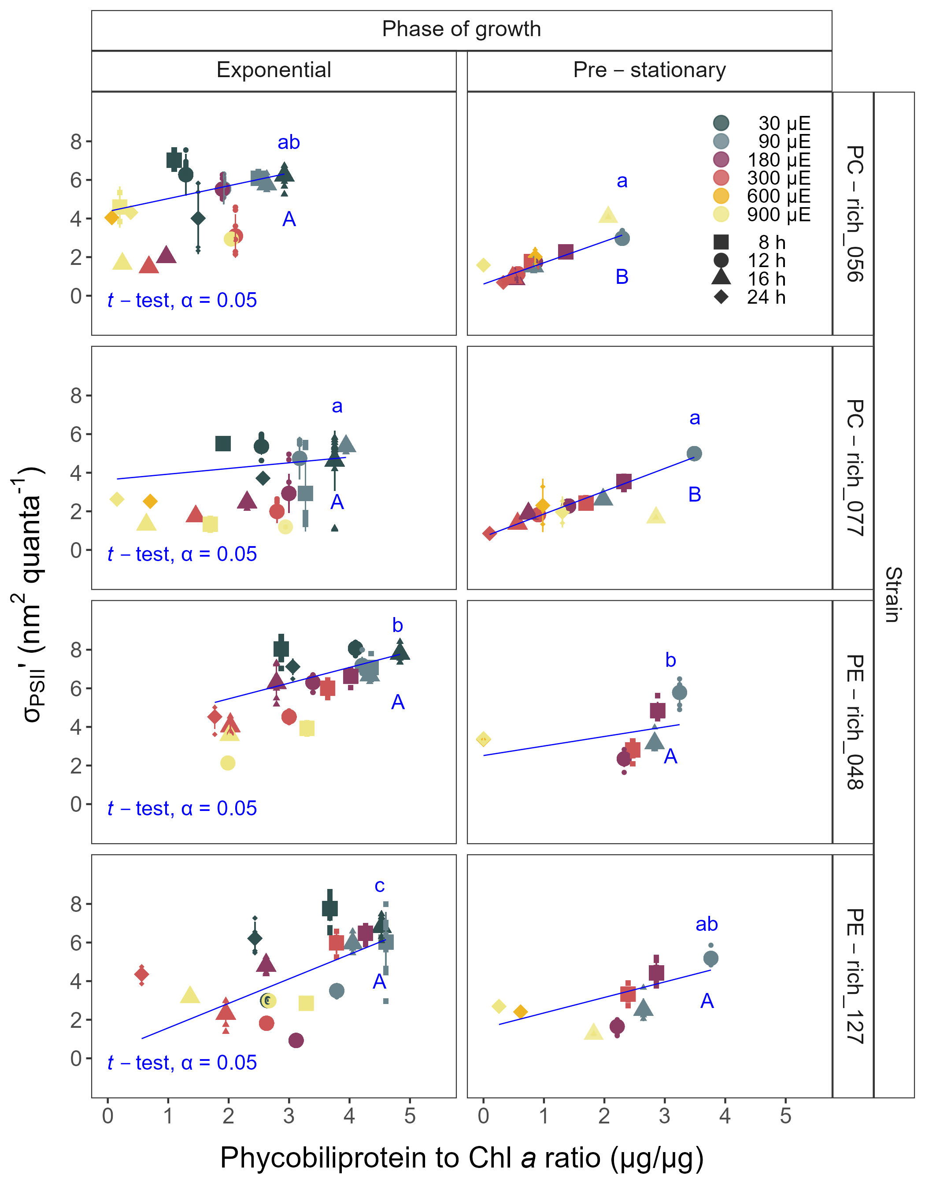

Figure 9: **Changes of effective absorption cross section of PSII** (σPSIIʹ; nm2 quanta−1) **measured under diel peak PAR growth light with excitation of phycobilisomes (Ex590nm, orange) vs. the ratio of sum of µg phycobilins (PE, PC, APC protein, Phycobiliprotein)/µg Chl *a*;** for two PhycoCyanin(PC)-rich cultures (056, 077) and two PhycoErythrin(PE)-rich cultures (048, 127) of *Synechococcus* sp. originating from the Baltic Sea. Cultures were grown at 30 (dark gray), 90 (light gray), 180 (purple), 300 (red), 600 (orange), or 900 (yellow) peak PAR µmol photons m−2s−1 (µE); and photoperiods of 8 (square), 12 (circle), 16 (triangle), or 24 (diamond) h. Figure presents data (smaller symbols) and means (bigger symbols) from exponential or pre-stationary phase of growth. Blue solid line shows linear model fit for data from each strain and growth phase. Different lowercase letters indicate statistically significant differences between the fit models for different strains within a given phase of growth. Different uppercase letters indicate statistically significant differences between the fit models for different phases of growth within a given strain (*t*-test; *p* < 0.05).

## Response of chlorophyll-specific exponential growth rates to cumulative diel PSII electron flux

Chlorophyll specific exponential growth rates (d−1), within each strain, show fairly consistent saturating responses to increasing cumulative diel PSII electron flux (*JV*PSII; µmol e− µmol Chl *a*−1 d−1) measured under diel peak PAR growth light and estimated using FRRf induction curves with excitation of chlorophyll (Ex445nm, blue), although photoperiod (Fig. 10, Table S7) and peak PAR (Fig. S11, Table S8) retained a secondary influence on achieved growth responses for some growth conditions.

A three parameter model fit of (Harrison and Platt 1986) vs. cumulative diel PSII electron flux (*JV*PSII; µmol e− µmol Chl *a*−1 d−1) for two PC-rich and two PE-rich cultures of *Synechococcus* sp. showed no significant differences between fits of the pooled data vs. fits for different photoperiods (8, 12, 16, or 24 h; ANOVA, *p* < 0.05), with exception of 8 and 24 h photoperiod for PC-rich_056 and 8 h photoperiod for PE-rich_127 strains (ANOVA, *p* > 0.05; Table S7).

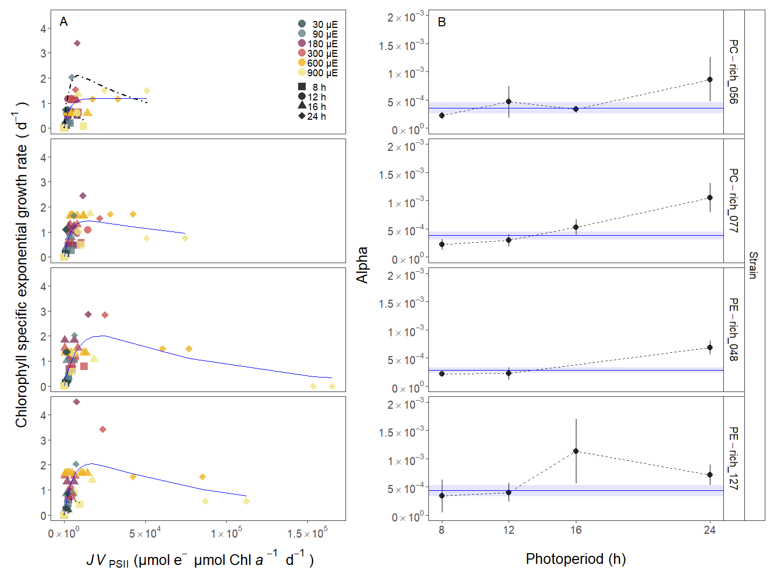

Figure 10: **Chlorophyll specific exponential growth rates (d−1) vs. cumulative diel PSII electron flux (*JV*PSII; µmol e− µmol Chl *a*−1 d−1) measured under diel peak PAR growth light.** **A.** Growth rates (+/- SE falling within symbols) were estimated from logistic fits of chlorophyll proxy OD680 - OD720 (ΔOD) vs. elapsed time (Fig. S4). PSII electron flux (*JV*PSII; µmol e− µmol Chl *a*−1 d−1) was estimated using FRRf induction curves with excitation of chlorophyll (Ex445nm, blue), for two PhycoCyanin(PC)-rich cultures (056, 077) and two PhycoErythrin(PE)-rich cultures (048, 127) of *Synechococcus* sp. originating from the Baltic Sea. Cultures were grown at 30 (dark gray), 90 (light gray), 180 (purple), 300 (red), 600 (orange), or 900 (yellow) peak PAR µmol photons m−2s−1 (µE); and photoperiods of 8 (square), 12 (circle), 16 (triangle), or 24 (diamond) h. Solid blue line shows a fit of the pooled growth rates for each strain, with a three parameter model (Harrison and Platt 1986). We also fit the same model separately for 8 (dotted line) and 24 (two dash line) h photoperiods, when they were significantly different (ANOVA, *p* < 0.05) from the fit of pooled data. **B.** Alpha parameters of the initial rise of growth rate vs. cumulative diel *JV*PSII, estimated from data pooled for each photoperiod (points (+/- SE) connected by dashed lines), and estimated for all data across photoperiods (horizontal line +/- SE), for each strain.

# Discussion

## Influences of photic regime on picocyanobacteria growth and implications for distribution

Light regimes, including peak level and photoperiod, are major factors affecting the distribution and seasonality of phytoplankters (Erga and Heimdal 1984). We found that cumulative diel PUR consistently explain achieved growth rates (µ; d−1) of PC-rich and PE-rich strains of *Synechococcus*, across a matrix of 4 photoperiods (8 – 24 h) and 6 peak PAR (30 – 900 µmol photons m−2s−1). All four strains showed saturation of growth rate under increasing cumulative diel PUR, although the achieved estimates of µmax, and the onset of photoinhibition of growth, varied depending upon strain, photoperiod and peak PAR (Fig. 4-5). Tested strains were generally opportunistic in exploiting higher diel light doses to achieve faster µ, although PE-rich strains suffered strong photoinhibition of growth under peak PAR above 600 µmol photons m−2s−1 and 24 h photoperiod. Plots of growth rates vs. cumulative diel PAR, estimated for exponential phase cultures, show similar patterns (Fig. S5-S6).

Here, we demonstrated that the maximum growth rate of *Synechococcus* sp. originating from the Baltic Sea in 24 h photoperiod and peak PAR of 180 µmol photons m−2s−1 was 4.5 d−1 (µ = 0.187 h−1) which corresponds to doubling time of 3.7 h (Fig. 4-5; Fig. S5-S6); a growth speed never reported for picocyanobacteria before. It is worth noting here that this doubling time of PE-rich *Synechococcus* sp. is faster than for freshwater *Synechococcus* sp. PCC6301 (doubling time of 4.5-5 h under constant illumination and 250 µmol photons m−2s−1) noted by Sakamoto and Bryant (1999) and even for model species *Synechocystis* sp. PCC 6803 (doubling time up to 4.3 h) described by van Alphen et al. (2018) and Zavřel et al. (2015). For comparison, the fastest achieved growth rate occurs in genetically modified green algae *Picochlorum celeri* with a maximum of about 6.8 d−1 and ~2.5 h doubling time under optimal growth conditions obtained in specially prepared bioreactors (Krishnan et al. 2021).

Changes in photoperiod trigger acclimation responses, shaping the temporal dynamics and community structure of phytoplankton (Theus et al. 2022; Longobardi et al. 2022) however, its effect on the cyanobacteria ecophysiology is not sufficiently and frequently investigated. We indeed find that each tested cyanobacterial strain shows specific influences of photoperiod, upon the response of growth rate to cumulative diel PUR (Fig. 4, S5). Both PC-rich and PE-rich strains of *Synechococcus* sp. exhibited the fastest growth rates under continuous light (24 h photoperiod). On the other hand, the least favorable growth conditions for both PE-rich and PC-rich strains of *Synechococcus* sp. were under high light (> 600 µmol photons m−2s−1) and the shortest photoperiod (8 h), even though the cumulative diel PUR dose was equivalent to conditions where the light intensity was lower and the photoperiod was longer. Jacob-Lopes et al. (2009) showed a linear reduction in biomass production of picocyanobacterium *Aphanothece microscopica* with reductions in the duration of the light period. Moreover, the effect of photoperiod on the growth rate of PC-rich *Synechococcus* PCC 6715 was examined by Klepacz-Smółka et al. (2020). In these studies, PC-rich picocyanobacteria also showed faster specific growth rate in 24 h photoperiod (µ = 2.0 d−1) than 16 h photoperiod (µ = 1.9 d−1), which confirmed the adaptation and preference of *Synechococcus* sp. to existence in continuous illumination conditions. Ability to grow both PC-rich and PE-rich picocyanobacteria under continuous light means they could, potentially, grow in a warmer polar summer water.

*Synechococcus* occurs in polar regions (reviewed in detail by Velichko et al. (2021)), exceeding even latitude 80°S and 80°N. During the Arctic or Antarctic summer, prolonged daylight hours, coupled with nutrient-rich waters, promote the growth of *Synechococcus* populations, contributing significantly to primary productivity. Furthermore, recent research suggests that *Synechococcus* populations in these polar regions exhibit genetic diversity. Gradinger and Lenz (1989) suggested that *Synechococcus*-type picocyanobacteria can serve as indicator organisms for the advection of warm water masses into polar regions, important in the context of monitoring upcoming climate changes.

Light level is another key driver of picocyanobacteria productivity (Pick 1991; Six et al. 2007; Flombaum et al. 2013; Six et al. 2021). PE-rich and PC-rich *Synechococcus* sp. strains show distinct growth responses to cumulative diel photon dose, depending upon peak PAR (Fig. 5, S6). In this study, chlorophyll specific exponential growth rates of the PE-rich and PC-rich *Synechococcus* sp. strains increased with increasing light levels, to a plateau in the range of 180 – 300 µmol photons m−2s−1. Growth above 600 µmol photons m−2s−1 occurred, but the growth yield per cumulative diel photon was lower than under moderate light. Even though PE-rich *Synechococcus* sp. are more adapted to lower-light conditions and remain deeper in the water column, our findings prove that several PE-rich strains will grow under higher irradiance.

*Synechococcus* sp., a widely studied picocyanobacterial genus, exhibits remarkable acclimation within a strain to different light intensities (Śliwińska-Wilczewska et al. 2018a, 2020; Aguilera et al. 2023). Under high light, *Synechococcus* employs photoprotective mechanisms to prevent the harmful effects of excess light energy. These include the dissipation of excess energy as heat via non-photochemical quenching (NPQ) and the regulation of phycobilisome antenna pigments, to balance light absorption and energy transfer. In contrast, under low-light conditions, *Synechococcus* sp. increases the expression of light-harvesting complexes to enhance light absorption and capture (Dufresne et al. 2008; Mella-Flores et al. 2012; Chen et al. 2022).

Large numbers of *Synechococcus* sp. are recorded in various geographical regions around the world (Śliwińska-Wilczewska et al. 2018b) and characterized by different photic regimes. Our work indicates that *Synechococcus* can persist under extreme light conditions and adapt to fluctuating photoperiods. Thus, in regions and periods with a longer photoperiod, both PC-rich and PE-rich *Synechococcus* sp. may become dominant species in the surface waters, but suffer when the photoperiod is shorter.

## Photic regime and growth phase influences on picocyanobacteria light capture

Phytoplankton, as primary producers, use PUR for photosynthesis. PUR is always smaller than PAR (PUR < PAR), and depends on the spectral composition of the PAR, versus the phytoplankton pigment composition determining spectral absorption (Morel 1978). The spatial and temporal distribution of PAR within aquatic ecosystems is influenced by solar angle, water depth, water clarity, and the presence of light-absorbing substances such as dissolved organic matter (Morel 1978, 1988) and phytoplankton cells. PUR, in turn, is also determined by pigment content of phytoplankton cells, which changes depending upon growth conditions and the phase of growth.

We found that under nutrient replete exponential growth strains show consistent patterns of PUR/PAR ratio versus cumulative diel photon doses, across different combinations of photoperiod and peak PAR. Although all strains show this response pattern, the exponential decay model parameters differ significantly among strains and phase of growth. The PE-rich strains show a much higher PUR/PAR ratio under low cumulative diel photon dose during their exponential phase of growth, but decay towards a plateau close to the PC-rich strains as cumulative diel photon dose increases (Fig. 6). Primary photosynthetic pigments in *Synechococcus* sp. comprise chlorophyll *a*, responsible for light energy capture. Under low-light conditions, picocyanobacteria tend to increase their chlorophyll *a* content to enhance light absorption and maximize energy capture for photosynthesis. Conversely, high-light conditions often lead to a decrease in chlorophyll *a* content, serving as a photoprotective mechanism against excessive irradiation. In addition to chlorophyll *a*, picocyanobacteria utilize phycobilins, including phycocyanin and phycoerythrin, as accessory pigments to enhance light harvesting efficiency. Adapting to low-light environments, picocyanobacteria enhance phycobilin production to compensate for limited irradiance, thereby optimizing their photosynthetic capabilities (Śliwińska-Wilczewska et al. 2018a). Our work proved that PE-rich strains in the exponential phase of growth demonstrated high ability to modulate light capacity whereas PC-rich strains almost fixed PUR/PAR ratio. It means that PE-rich strains of *Synechococcus* sp. better exploit available radiation under low cumulative diel photon dose during their exponential phase of growth than PC-rich strains due to the greater plasticity of their photosynthetic pigments.

What is more, during pre-stationary phase of growth, the response of PUR/PAR for PC-rich and PE-rich strains remains constant even when cumulative diel photon dose increases. A possible explanation for this observation may be a high CO2 concentration in the culture medium. Mou et al. (2018) demonstrated that elevated CO2 increased the light utilization efficiency during the exponential and stationary phases, and elevated the phycobilisome:chlorophyll *a* ratio in *Synechococcus* sp. This means that even aging cells undergoing physiological regulations are able to maintain the total pigment content at a level that allows them to evenly absorb available energy, regardless of the prevailing phototic regime, as long as they have access to high concentrations of CO2.

## Effective absorption cross section of PSII and cumulative diel PSII electron flux of PC-rich and PE-rich picocyanobacteria

The effective absorption cross section for photochemistry of PSII in the light (PSIIʹ) comprises the probability of light capture by PSII and the quantum yield for subsequent photochemistry. In this work, PSIIʹ (nm2 quanta−1) was measured under diel peak PAR growth light under Ex590nm (orange) excitation for two PC-rich and two PE-rich cultures of *Synechococcus* sp. originating from the Baltic Sea in relation to cumulative diel PAR, across different combinations of photoperiod and peak PAR (Fig. 7). We find, for the first time, that PC-rich and PE-rich strains of *Synechococcus* show consistent patterns of effective absorption cross section for PSII photochemistry, versus increasing cumulative diel PAR doses, with no statistically detectable influence of photoperiod nor of peak PAR in our determinations. Moreover, we demonstrated that the PSIIʹ excited through chlorophyll absorbance at 445 nm was consistently small across strains and growth conditions (Fig. S9), since in cyanobacteria the number of chlorophyll serving PSII is nearly fixed (Xu et al. 2018).

The growth phases are also important factors in the yield of photosynthetic reactions (Jacob-Lopes et al. 2009; Schuurmans et al. 2017). We showed that the exponential decay model parameters differ significantly among phases of growth. During the exponential phase of growth, The PE-rich strains show a much higher PSIIʹ under low cumulative diel photon dose, and remain higher than the PC-rich strains even as cumulative diel photon dose increases. During pre-stationary phase this response dampens but persists. (XXXMore about sigmaXXX).

For PSIIʹ excited through phycobilisome absorbance at 590 nm, strains show consistent positive correlation with phycobilin:chlorophyll ratio. The chlorophyll/phycobilin ratio serves as a valuable indicator of the prevailing light conditions and the balance between chlorophyll-based and phycobilin-based light harvesting strategies. Elevated light intensities result in a decreased chlorophyll/phycobilin ratio as picocyanobacteria allocate resources towards efficient phycobilin-mediated light capture. These intricate changes in pigment composition and ratios represent vital adaptations that enable picocyanobacteria to optimize photosynthetic efficiency and thrive in dynamic light environments (Beale 1994; Stadnichuk et al. 2015; Chakdar and Pabbi 2016). Our work demonstrated that PC-rich and PE-rich strains of *Synechococcus* sp. in exponential growth show significant scatter around this positive relation, likely related to regulatory control of PSIIʹ, beyond pigment composition. Under pre-stationary phase PSIIʹ vs. Phycobiliprotein to Chl *a* ratio was better aligned, suggesting an increase in reliance upon compositional regulation to control light delivery to PSII, as opposed to shorter-term regulation.

Responses in relation to photoperiod and irradiance can vary among the species and for pigments in the same species of algae (Zucchi and Necchi Jr 2001). Our results showed significant differences in light capture between PC-rich and PE-rich picocyanobacteria. This work indicate that PE-rich strains are stronger light-harvesting competitors, consistent with their typical deeper distribution in the water column, while the PC-rich strains may have lower N-quotients for their light capture system (García-Sánchez et al. 2014; Mackey et al. 2017) (XXXMore about this statementXXX).

Our results showed the PE-rich strains are stronger light-harvesting competitors, consistent with their typical deeper distribution in the water column, while the PC-rich strains may have lower N-quotients for their light capture system (García-Sánchez et al. 2014; Mackey et al. 2017)

(Riethman et al. 1988; Ho et al. 2017; Han et al. 2017; Mou et al. 2018).

FIX THIS SYLWIA! JVPSII Oxborough et al. (2012) Ramírez et al. (2024) Lei (2018) Connor (2018) Keys (2018) Giannini (2016) Bhagooli et al. (2021)

# Conclusion

This study focused on the reaction to photic regime controlling photosynthesis and growth rate of PC-rich and PE-rich *Synechococcus* sp. since understanding the temporal progression of growth phases of different lineages is essential for predicting picocyanobacterial activity and their impact on ecosystem dynamics. We found that picocyanobacteria showed different ecophysiological responses to the prevailing photoperiod and light level, even if the cumulative diel PUR dose remains the same. Both PE-rich and PC-rich strains of *Synechococcus* sp., grew the fastest under low light and the longest photoperiod. This is particularly important in polar regions, where prolonged daylight hours coupled with nutrient-rich waters may promote growth of the *Synechococcus* populations. Consequently, *Synechococcus* sp. has the potential to eventually emerge as phytoplankton components during the Arctic or Antarctic summer near polar regions. In optimal conditions (24 h of photoperiod and a peak PAR of 180 µmol photons m−2s−1), one of the PE-rich *Synechococcus* sp., reached the highest chlorophyll-specific exponential growth rate of 4.5 d−1 (3.7 h doubling time) on record for cyanobacteria. PE-rich strains in the exponential phase of growth also demonstrated high ability to modulate the PUR/PAR ratio that likely allowed this remarkable growth rate. Additionally, we presented for the first time, the consistent patterns of effective absorption cross section for PSII photochemistry excited through phycobilisome absorbance at 590 nm in PC-rich and PE-rich picocyanobacteria. Positive correlation with phycobilin:chlorophyll ratio is likely related to regulatory control of PSIIʹ, beyond pigment composition. Our results indicates that the PE-rich strains are stronger light-harvesting competitors, while the PC-rich strains may have lower N-quotients for their light capture system. XXXXXYOU DO NOT PRESENT ANY DATA NOR ANALYSES TO SUPPORT THIS POINT; SUPPORT OR DROP IT FROM THE CONCLUSIONS. In this study, we also calibrated the *JV*PSII estimator to absolute rates of the electron transport using parallel measures of oxygen evolution, captured simultaneously to the FRRf measures, which finally allow to compute and compare growth yield of PC-rich and PE-rich picocyanobacteria vs. cumulative diel PSII electron flux. These differences may help explain differential seasonal prevalences of *Synechococcus* sp., in terms of differential costs of exploitation of different photic regimes.

Differences in growth and light capture between PC-rich and PE-rich *Synechococcus* sp. could influence the fluctuation of picocyanobacterial biomass and the composition of its community lineage over space and time in existing and potential aquatic environments relating to varying metabolic costs between different physiological strategies for growth.

Our findings show that *Synechococcus* sp., can thrive under continuous irradiation, but suffer growth inhibition at peak PAR > 600 µmol photons m−2s−1. Consequently, *Synechococcus* sp. has the potential to eventually emerge as phytoplankton components during the Arctic or Antarctic summer near polar regions.

# Acknowledgements

We thank Miranda Corkum who maintained cultures and trained personnel in culture handling, Mireille Savoie, Laurel Genge, and Carlie Barnhill (Mount Allison student) who assisted with R code.

# Funding sources

Canada Research Chair in Phytoplankton Ecophysiology (DAC)

Latitude & Light; NSERC of Canada Discovery Grant (DAC)

# Data sources

Data sources chapter provide links to any data used from external providers:

URL for MetaDataCatalog: <https://docs.google.com/spreadsheets/d/1ZXpwR7Gfto-uRzVdXzMpQF4frbrvMLH_IyLqonFZRSw/edit#gid=0>

URL for tMaxAHG Catalog: <https://docs.google.com/spreadsheets/d/1ksY7xlg9wOsICOBRmZkHPKdd9KOislNwPDzyuJ3UIUI/edit#gid=0>

URL for pigments Catalog (correlation): <https://docs.google.com/spreadsheets/d/1EvogE5pFlGT9H304E3dqXKwh26dWI9r_snSPhZCHWiU/edit#gid=0>

URL for ClarioStar Growth Catalog (correlation): <https://docs.google.com/spreadsheets/d/1cfyxO1bFSeEMlMnx1vAyuskk3Un_bqkE9-uUSc-jwhE/edit#gid=0>

# References

Aguilera, A., J. Alegria Zufia, L. Bas Conn, and others. 2023. Ecophysiological analysis reveals distinct environmental preferences in closely related Baltic Sea picocyanobacteria. Environmental Microbiology **n/a**: 1–12. doi:[10.1111/1462-2920.16384](https://doi.org/10.1111/1462-2920.16384)

Alberte, R. S., E. Tel-Or, L. Packer, and J. P. Thornber. 1980. Functional organisation of the photo-synthetic apparatus in heterocysts of nitrogen-fixing cyanobacteria. Nature **284**: 481–483. doi:[10.1038/284481a0](https://doi.org/10.1038/284481a0)

Arrigo, K. R. 2014. Sea ice ecosystems. Annual Review of Marine Science **6**: 439–467. doi:[10.1146/annurev-marine-010213-135103](https://doi.org/10.1146/annurev-marine-010213-135103)

Beale, S. I. 1994. [Biosynthesis of Cyanobacterial Tetrapyrrole Pigments: Hemes, Chlorophylls, and Phycobilins](https://doi.org/10.1007/978-94-011-0227-8_17), p. 519–558. *In* D.A. Bryant [ed.], The Molecular Biology of Cyanobacteria. Springer Netherlands.

Behrenfeld, M. J., R. T. O’Malley, D. A. Siegel, and others. 2006. Climate-driven trends in contemporary ocean productivity. Nature **444**: 752–755. doi:[10.1038/nature05317](https://doi.org/10.1038/nature05317)

Bennett, A., and L. Bogorad. 1973. COMPLEMENTARY CHROMATIC ADAPTATION IN A FILAMENTOUS BLUE-GREEN ALGA. Journal of Cell Biology **58**: 419–435. doi:[10.1083/jcb.58.2.419](https://doi.org/10.1083/jcb.58.2.419)

Bhagooli, R., S. Mattan-Moorgawa, D. Kaullysing, and others. 2021. Chlorophyll fluorescence – A tool to assess photosynthetic performance and stress photophysiology in symbiotic marine invertebrates and seaplants. Marine Pollution Bulletin **165**: 112059. doi:[10.1016/j.marpolbul.2021.112059](https://doi.org/10.1016/j.marpolbul.2021.112059)

Blake, R., and M. Griff. 2012. In situ spectroscopy on intact Leptospirillum ferrooxidans reveals that reduced cytochrome 579 is an obligatory intermediate in the aerobic iron respiratory chain. Frontiers in Microbiology **3**.

Boatman, T. G., R. J. Geider, and K. Oxborough. 2019. Improving the Accuracy of Single Turnover Active Fluorometry (STAF) for the Estimation of Phytoplankton Primary Productivity (PhytoPP). Frontiers in Marine Science **6**. doi:[10.3389/fmars.2019.00319](https://doi.org/10.3389/fmars.2019.00319)

Bracher, A., H. A. Bouman, R. J. W. Brewin, and others. 2017. Obtaining Phytoplankton Diversity from Ocean Color: A Scientific Roadmap for Future Development. Frontiers in Marine Science **4**.

Chakdar, H., and S. Pabbi. 2016. [Cyanobacterial Phycobilins: Production, Purification, and Regulation](https://doi.org/10.1007/978-81-322-2610-9_4), p. 45–69. *In* P. Shukla [ed.], Frontier Discoveries and Innovations in Interdisciplinary Microbiology. Springer India.

Chen, J., Y. Li, H. Jing, X. Zhang, Z. Xu, J. Xu, and H. Liu. 2022. Genomic and transcriptomic evidence for the diverse adaptations of Synechococcus subclusters 5.2 and 5.3 to mesoscale eddies. New Phytologist **233**: 1828–1842. doi:[10.1111/nph.17903](https://doi.org/10.1111/nph.17903)

Christaki, U., S. Jacquet, J. R. Dolan, D. Vaulot, and F. Rassoulzadegan. 1999. Growth and grazing on Prochlorococcus and Synechococcus by two marine ciliates. Limnology and Oceanography **44**: 52–61. doi:[10.4319/lo.1999.44.1.0052](https://doi.org/10.4319/lo.1999.44.1.0052)

Connor, D. 2018. Investigating the use of fast repetition rate fluorometry in understanding algal physiology in optically complex oceans.

Dufresne, A., M. Ostrowski, D. J. Scanlan, and others. 2008. Unraveling the genomic mosaic of a ubiquitous genus of marine cyanobacteria. Genome Biology **9**: R90. doi:[10.1186/gb-2008-9-5-r90](https://doi.org/10.1186/gb-2008-9-5-r90)

Elzhov, T. V., K. M. Mullen, A.-N. Spiess, and B. Bolker. 2023. Minpack.lm: R Interface to the Levenberg-Marquardt Nonlinear Least-Squares Algorithm Found in MINPACK, Plus Support for Bounds.

Erga, S. R., and B. R. Heimdal. 1984. Ecological studies on the phytoplankton of Korsfjorden, western Norway. The dynamics of a spring bloom seen in relation to hydrographical conditions and light regime. Journal of Plankton Research **6**: 67–90. doi:[10.1093/plankt/6.1.67](https://doi.org/10.1093/plankt/6.1.67)

Falkowski, P., and Z. Kolber. 1993. Estimation of phytoplankton photosynthesis by active fluorescence. ICES Marine Science Symposium **197**: 92–103.

Field, C. B., M. J. Behrenfeld, J. T. Randerson, and P. Falkowski. 1998. Primary Production of the Biosphere: Integrating Terrestrial and Oceanic Components. Science **281**: 237–240. doi:[10.1126/science.281.5374.237](https://doi.org/10.1126/science.281.5374.237)

Fishwick, J. R., J. Aiken, R. Barlow, H. Sessions, S. Bernard, and J. Ras. 2006. Functional relationships and bio-optical properties derived from phytoplankton pigments, optical and photosynthetic parameters; a case study of the Benguela ecosystem. Journal of the Marine Biological Association of the United Kingdom **86**: 1267–1280. doi:[10.1017/S0025315406014287](https://doi.org/10.1017/S0025315406014287)

Flombaum, P., J. L. Gallegos, R. A. Gordillo, and others. 2013. Present and future global distributions of the marine Cyanobacteria Prochlorococcus and Synechococcus. Proceedings of the National Academy of Sciences **110**: 9824–9829. doi:[10.1073/pnas.1307701110](https://doi.org/10.1073/pnas.1307701110)

García-Sánchez, M., N. Korbee, I. M. Pérez-Ruzafa, C. Marcos, F. L. Figueroa, and Á. Pérez-Ruzafa. 2014. Living in a coastal lagoon environment: Photosynthetic and biochemical mechanisms of key marine macroalgae. Marine Environmental Research **101**: 8–21. doi:[10.1016/j.marenvres.2014.07.012](https://doi.org/10.1016/j.marenvres.2014.07.012)

Giannini, M. F. C. 2016. [The influence of phytoplankton pigments composition and dominant cell size on fluorescence-derived photophysiological parameters and implications for primary production rates](https://doi.org/10.11606/T.21.2016.tde-08122016-114954). Text. Universidade de São Paulo.

Gradinger, R., and J. Lenz. 1989. Picocyanobacteria in the high Arctic. Marine Ecology Progress Series **52**: 99–101. doi:[10.3354/meps052099](https://doi.org/10.3354/meps052099)

Grébert, T., H. Doré, F. Partensky, and others. 2018. Light color acclimation is a key process in the global ocean distribution of Synechococcus cyanobacteria. Proceedings of the National Academy of Sciences **115**: E2010–E2019. doi:[10.1073/pnas.1717069115](https://doi.org/10.1073/pnas.1717069115)

Guillard, R. R. L. 1975. [Culture of Phytoplankton for Feeding Marine Invertebrates](https://doi.org/10.1007/978-1-4615-8714-9_3), p. 29–60. *In* W.L. Smith and M.H. Chanley [eds.], Culture of Marine Invertebrate Animals: Proceedings — 1st Conference on Culture of Marine Invertebrate Animals Greenport. Springer US.

Han, P., S. Shen, R. Guo, S. Yao, Y. Sun, Z. Tan, and S. Jia. 2017. The regulation of photosynthetic pigments in terrestrial *Nostoc* *Flagelliforme* in response to different light colors. Algal Research **25**: 128–135. doi:[10.1016/j.algal.2017.04.009](https://doi.org/10.1016/j.algal.2017.04.009)

Handel, A. 2020. Andreas Handel - Custom Word formatting using R Markdown.

Harrison, W. G., and T. Platt. 1986. Photosynthesis-irradiance relationships in polar and temperate phytoplankton populations. Polar biology **5**: 153–164.

Haverkamp, T. H. A., D. Schouten, M. Doeleman, U. Wollenzien, J. Huisman, and L. J. Stal. 2009. Colorful microdiversity of *Synechococcus* strains (picocyanobacteria) isolated from the Baltic Sea. The ISME Journal **3**: 397–408. doi:[10.1038/ismej.2008.118](https://doi.org/10.1038/ismej.2008.118)

Hirata, T., N. J. Hardman-Mountford, R. J. W. Brewin, and others. 2011. Synoptic relationships between surface Chlorophyll-*a* and diagnostic pigments specific to phytoplankton functional types. Biogeosciences **8**: 311–327. doi:[10.5194/bg-8-311-2011](https://doi.org/10.5194/bg-8-311-2011)

Ho, M.-Y., N. T. Soulier, D. P. Canniffe, G. Shen, and D. A. Bryant. 2017. Light regulation of pigment and photosystem biosynthesis in cyanobacteria. Current Opinion in Plant Biology **37**: 24–33. doi:[10.1016/j.pbi.2017.03.006](https://doi.org/10.1016/j.pbi.2017.03.006)

Holtrop, T., J. Huisman, M. Stomp, and others. 2021. Vibrational modes of water predict spectral niches for photosynthesis in lakes and oceans. Nature Ecology & Evolution **5**: 55–66. doi:[10.1038/s41559-020-01330-x](https://doi.org/10.1038/s41559-020-01330-x)

Huisman, J., M. Arrayás, U. Ebert, and B. Sommeijer. 2002. How Do Sinking Phytoplankton Species Manage to Persist? The American Naturalist **159**: 245–254. doi:[10.1086/338511](https://doi.org/10.1086/338511)

Hutchins, D. A., and P. W. Boyd. 2016. Marine phytoplankton and the changing ocean iron cycle. Nature Climate Change **6**: 1072–1079. doi:[10.1038/nclimate3147](https://doi.org/10.1038/nclimate3147)

Jacob-Lopes, E., C. H. G. Scoparo, L. M. C. F. Lacerda, and T. T. Franco. 2009. Effect of light cycles (night/day) on CO2 fixation and biomass production by microalgae in photobioreactors. Chemical Engineering and Processing: Process Intensification **48**: 306–310. doi:[10.1016/j.cep.2008.04.007](https://doi.org/10.1016/j.cep.2008.04.007)

Jávorfi, T., J. Erostyák, J. Gál, A. Buzády, L. Menczel, G. Garab, and K. Razi Naqvi. 2006. Quantitative spectrophotometry using integrating cavities. Journal of Photochemistry and Photobiology B: Biology **82**: 127–131. doi:[10.1016/j.jphotobiol.2005.10.002](https://doi.org/10.1016/j.jphotobiol.2005.10.002)

Keys, M. 2018. Effect of future CO2 and temperature regimes on phytoplankton community composition, biomass and photosynthetic rates in the western English Channel. PhD thesis. University of Essex.

Kirk, J. T. O. 1983. Light and Photosynthesis in Aquatic Ecosystems.

Klepacz-Smółka, A., D. Pietrzyk, R. Szeląg, P. Głuszcz, M. Daroch, J. Tang, and S. Ledakowicz. 2020. Effect of light colour and photoperiod on biomass growth and phycocyanin production by *Synechococcus* PCC 6715. Bioresource Technology **313**: 123700. doi:[10.1016/j.biortech.2020.123700](https://doi.org/10.1016/j.biortech.2020.123700)

Kolber, Z. S., O. Prášil, and P. G. Falkowski. 1998. Measurements of variable chlorophyll fluorescence using fast repetition rate techniques: Defining methodology and experimental protocols. Biochimica et Biophysica Acta (BBA) - Bioenergetics **1367**: 88–106. doi:[10.1016/S0005-2728(98)00135-2](https://doi.org/10.1016/S0005-2728(98)00135-2)

Krishnan, A., M. Likhogrud, M. Cano, and others. 2021. Picochlorum celeri as a model system for robust outdoor algal growth in seawater. Scientific Reports **11**: 11649. doi:[10.1038/s41598-021-91106-5](https://doi.org/10.1038/s41598-021-91106-5)

LaRoche, J., and B. M. Robicheau. 2022. [The Pelagic Light-Dependent Microbiome](https://doi.org/10.1007/978-3-030-90383-1_9), p. 395–423. *In* L.J. Stal and M.S. Cretoiu [eds.], The Marine Microbiome. Springer International Publishing.

Lei, Y. 2018. Variation in photosynthetic electron requirements for carbon fixation by Dunaliella tertiolecta during transient phases with different phosphorus availability. Master’s thesis.

Li, Q., L. Legendre, and N. Jiao. 2015. Phytoplankton responses to nitrogen and iron limitation in the tropical and subtropical Pacific Ocean. Journal of Plankton Research **37**: 306–319. doi:[10.1093/plankt/fbv008](https://doi.org/10.1093/plankt/fbv008)

Li, W. K. W. 1995. [Composition of ultraphytoplankton in the central North Atlantic](https://www.jstor.org/stable/24852252). Marine Ecology Progress Series **122**: 1–8.

Ligges, U., T. Short, P. Kienzle, and others. 2024. Signal: Signal Processing.

Longobardi, L., L. Dubroca, F. Margiotta, D. Sarno, and A. Zingone. 2022. Photoperiod-driven rhythms reveal multi-decadal stability of phytoplankton communities in a highly fluctuating coastal environment. Scientific Reports **12**: 3908. doi:[10.1038/s41598-022-07009-6](https://doi.org/10.1038/s41598-022-07009-6)

Mackey, K. R. M., A. F. Post, M. R. McIlvin, and M. A. Saito. 2017. Physiological and proteomic characterization of light adaptations in marine Synechococcus. Environmental Microbiology **19**: 2348–2365. doi:[10.1111/1462-2920.13744](https://doi.org/10.1111/1462-2920.13744)

Mella-Flores, D., C. Six, M. Ratin, and others. 2012. Prochlorococcus and Synechococcus have Evolved Different Adaptive Mechanisms to Cope with Light and UV Stress. Frontiers in Microbiology **3**.

Moejes, F. W., A. Matuszyńska, K. Adhikari, and others. 2017. A systems-wide understanding of photosynthetic acclimation in algae and higher plants. Journal of Experimental Botany **68**: 2667–2681. doi:[10.1093/jxb/erx137](https://doi.org/10.1093/jxb/erx137)

Morel, A. 1978. Available, usable, and stored radiant energy in relation to marine photosynthesis. Deep Sea Research **25**: 673–688. doi:[10.1016/0146-6291(78)90623-9](https://doi.org/10.1016/0146-6291(78)90623-9)

Morel, A. 1988. Optical modeling of the upper ocean in relation to its biogenous matter content (case I waters). Journal of Geophysical Research: Oceans **93**: 10749–10768. doi:[10.1029/JC093iC09p10749](https://doi.org/10.1029/JC093iC09p10749)

Mou, S., G. Li, H. Li, F. Li, Z. Shao, J. Li, C. Qu, and Y. Zhang. 2018. Differential physiological responses of the coastal cyanobacterium Synechococcus sp. PCC7002 to elevated pCO2 at lag, exponential, and stationary growth phases. Science China Earth Sciences **61**: 1397–1405. doi:[10.1007/s11430-017-9206-5](https://doi.org/10.1007/s11430-017-9206-5)

Ortmann, A. C., J. E. Lawrence, and C. A. Suttle. 2002. [Lysogeny and Lytic Viral Production during a Bloom of the Cyanobacterium Synechococcus spp.](https://www.jstor.org/stable/4287591) Microbial Ecology **43**: 225–231.

Oxborough, K., and N. R. Baker. 1997. Resolving chlorophyll a fluorescence images of photosynthetic efficiency into photochemical and non-photochemical components – calculation of qP and Fv-/Fm-; without measuring Fo-; Photosynthesis Research **54**: 135–142. doi:[10.1023/A:1005936823310](https://doi.org/10.1023/A:1005936823310)

Oxborough, K., C. M. Moore, D. J. Suggett, T. Lawson, H. G. Chan, and R. J. Geider. 2012. Direct estimation of functional PSII reaction center concentration and PSII electron flux on a volume basis: A new approach to the analysis of Fast Repetition Rate fluorometry (FRRf) data. Limnology and Oceanography: Methods **10**: 142–154. doi:[10.4319/lom.2012.10.142](https://doi.org/10.4319/lom.2012.10.142)

Pedersen, T. L. 2024. Patchwork: The Composer of Plots.

Pick, F. R. 1991. The abundance and composition of freshwater picocyanobacteria in relation to light penetration. Limnology and Oceanography **36**: 1457–1462. doi:[10.4319/lo.1991.36.7.1457](https://doi.org/10.4319/lo.1991.36.7.1457)

R Core Team, R. 2019. R: A Language and Environment for Statistical Computing. R Foundation for Statistical Computing. Vienna, Austria.

Ramírez, L., L. J. Pozzo-Pirotta, A. Trebec, and others. 2024. Ocean Alkalinity Enhancement (OAE) does not cause cellular stress in a phytoplankton community of the sub-tropical Atlantic Ocean. EGUsphere 1–34. doi:[10.5194/egusphere-2024-847](https://doi.org/10.5194/egusphere-2024-847)

Reynolds, C. S. 2006. The Ecology of Phytoplankton, Cambridge University Press.

Riethman, H., G. Bullerjahn, K. J. Reddy, and L. A. Sherman. 1988. [Regulation of cyanobacterial pigment-protein composition and organization by environmental factors](https://doi.org/10.1007/978-94-009-2269-3_11), p. 229–257. *In* Govindjee [ed.], Molecular Biology of Photosynthesis. Springer Netherlands.

Ryan, J. A., J. M. Ulrich, R. Bennett, and C. Joy. 2024. Xts: eXtensible Time Series.

Sakamoto, T., and D. A. Bryant. 1999. Nitrate Transport and Not Photoinhibition Limits Growth of the Freshwater Cyanobacterium Synechococcus Species PCC 6301 at Low Temperature1. Plant Physiology **119**: 785–794. doi:[10.1104/pp.119.2.785](https://doi.org/10.1104/pp.119.2.785)

Schraga, T. S., and J. E. Cloern. 2017. Water quality measurements in San Francisco Bay by the U.S. Geological Survey, 1969–2015. Scientific Data **4**: 170098. doi:[10.1038/sdata.2017.98](https://doi.org/10.1038/sdata.2017.98)

Schuurmans, R. M., J. C. P. Matthijs, and K. J. Hellingwerf. 2017. Transition from exponential to linear photoautotrophic growth changes the physiology of Synechocystis sp. PCC 6803. Photosynthesis Research **132**: 69–82. doi:[10.1007/s11120-016-0329-8](https://doi.org/10.1007/s11120-016-0329-8)

Serway, R. A., C. J. Moses, and C. A. Moyer. 2004. Modern Physics, Cengage Learning.

Six, C., Z. V. Finkel, A. J. Irwin, and D. A. Campbell. 2007. Light Variability Illuminates Niche-Partitioning among Marine Picocyanobacteria. PLOS ONE **2**: e1341. doi:[10.1371/journal.pone.0001341](https://doi.org/10.1371/journal.pone.0001341)

Six, C., M. Ratin, D. Marie, and E. Corre. 2021. Marine Synechococcus picocyanobacteria: Light utilization across latitudes. Proceedings of the National Academy of Sciences **118**: e2111300118. doi:[10.1073/pnas.2111300118](https://doi.org/10.1073/pnas.2111300118)

Śliwińska-Wilczewska, S., A. Cieszyńska, J. Maculewicz, and A. Latała. 2018a. Ecophysiological characteristics of red, green, and brown strains of the Baltic picocyanobacterium *Synechococcus* sp. – a laboratory study. Biogeosciences **15**: 6257–6276. doi:[10.5194/bg-15-6257-2018](https://doi.org/10.5194/bg-15-6257-2018)

Śliwińska-Wilczewska, S., Z. Konarzewska, K. Wiśniewska, and M. Konik. 2020. Photosynthetic Pigments Changes of Three Phenotypes of Picocyanobacteria Synechococcus sp. Under Different Light and Temperature Conditions. Cells **9**: 2030. doi:[10.3390/cells9092030](https://doi.org/10.3390/cells9092030)

Śliwińska-Wilczewska, S., J. Maculewicz, A. Barreiro Felpeto, and A. Latała. 2018b. Allelopathic and Bloom-Forming Picocyanobacteria in a Changing World. Toxins **10**: 48. doi:[10.3390/toxins10010048](https://doi.org/10.3390/toxins10010048)

Stadnichuk, I. N., P. M. Krasilnikov, and D. V. Zlenko. 2015. Cyanobacterial phycobilisomes and phycobiliproteins. Microbiology **84**: 101–111. doi:[10.1134/S0026261715020150](https://doi.org/10.1134/S0026261715020150)

Strickland, J. D., and T. R. Parsons. 1972. Practical Hand Book of Seawater Analysis. Fisheries Research Board of Canada **167 (2nd edition)**: 1–311. doi:<DOI: http://dx.doi.org/10.25607/OBP-1791>

Team, RStudio. 2015. RStudio: Integrated Development Environment for R. Boston, MA: RStudio, Inc.

Theus, M. E., T. J. Layden, N. McWilliams, S. Crafton-Tempel, C. T. Kremer, and S. B. Fey. 2022. Photoperiod influences the shape and scaling of freshwater phytoplankton responses to light and temperature. Oikos **2022**: e08839. doi:[10.1111/oik.08839](https://doi.org/10.1111/oik.08839)

Torremorell, A., M. E. Llames, G. L. Pérez, R. Escaray, J. Bustingorry, and H. Zagarese. 2009. Annual patterns of phytoplankton density and primary production in a large, shallow lake: The central role of light. Freshwater Biology **54**: 437–449. doi:[10.1111/j.1365-2427.2008.02119.x](https://doi.org/10.1111/j.1365-2427.2008.02119.x)

Tortell, P., D. J. Suggett, and S. W. Group156. 2021. [A User Guide for the Application of Single Turnover Active Chlorophyll Fluorescence for Phytoplankton Productivity Measurements. Version 1.](https://doi.org/10.25607/OBP-1084) Report Scientific Committee on Oceanic Research (SCOR) Working Group 156.

van Alphen, P., H. Abedini Najafabadi, F. Branco dos Santos, and K. J. Hellingwerf. 2018. Increasing the Photoautotrophic Growth Rate of Synechocystis sp. PCC 6803 by Identifying the Limitations of Its Cultivation. Biotechnology Journal **13**: 1700764. doi:[10.1002/biot.201700764](https://doi.org/10.1002/biot.201700764)

Velichko, N., S. Smirnova, S. Averina, and A. Pinevich. 2021. A survey of Antarctic cyanobacteria. Hydrobiologia **848**: 2627–2653.

Vidussi, F., H. Claustre, B. B. Manca, A. Luchetta, and J.-C. Marty. 2001. Phytoplankton pigment distribution in relation to upper thermocline circulation in the eastern Mediterranean Sea during winter. Journal of Geophysical Research: Oceans **106**: 19939–19956. doi:[10.1029/1999JC000308](https://doi.org/10.1029/1999JC000308)

Wickham, H. 2016. [Data Analysis](https://doi.org/10.1007/978-3-319-24277-4_9), p. 189–201. *In* H. Wickham [ed.], Ggplot2: Elegant Graphics for Data Analysis. Springer International Publishing.

Wlodkowic, D., A. Czerw, B. Karakiewicz, and A. Deptała. 2022. Recent progress in cytometric technologies and their applications in ecotoxicology and environmental risk assessment. Cytometry Part A **101**: 203–219. doi:[10.1002/cyto.a.24508](https://doi.org/10.1002/cyto.a.24508)

Wood, S. 2023. Mgcv: Mixed GAM Computation Vehicle with Automatic Smoothness Estimation.

Wood, S. N. 2017. [Generalized Additive Models: An Introduction with R, Second Edition](https://doi.org/10.1201/9781315370279), 2nd ed. Chapman and Hall/CRC.

Xi, H., S. N. Losa, A. Mangin, and others. 2020. Global retrieval of phytoplankton functional types based on empirical orthogonal functions using CMEMS GlobColour merged products and further extension to OLCI data. Remote Sensing of Environment **240**: 111704. doi:[10.1016/j.rse.2020.111704](https://doi.org/10.1016/j.rse.2020.111704)

Xu, K., J. L. Grant-Burt, N. Donaher, and D. A. Campbell. 2017. Connectivity among Photosystem II centers in phytoplankters: Patterns and responses. Biochimica et Biophysica Acta (BBA) - Bioenergetics **1858**: 459–474. doi:[10.1016/j.bbabio.2017.03.003](https://doi.org/10.1016/j.bbabio.2017.03.003)

Xu, K., J. Lavaud, R. Perkins, E. Austen, M. Bonnanfant, and D. A. Campbell. 2018. Phytoplankton $σ$ PSII and Excitation Dissipation; Implications for Estimates of Primary Productivity. Frontiers in Marine Science **5**. doi:[10.3389/fmars.2018.00281](https://doi.org/10.3389/fmars.2018.00281)

Zavřel, T., M. A. Sinetova, D. Búzová, P. Literáková, and J. Červený. 2015. Characterization of a model cyanobacterium Synechocystis sp. PCC 6803 autotrophic growth in a flat-panel photobioreactor. Engineering in Life Sciences **15**: 122–132. doi:[10.1002/elsc.201300165](https://doi.org/10.1002/elsc.201300165)

Zucchi, M. R., and O. Necchi Jr. 2001. Effects of temperature, irradiance and photoperiod on growth and pigment content in some freshwater red algae in culture. Phycological Research **49**: 103–114. doi:[10.1046/j.1440-1835.2001.00230.x](https://doi.org/10.1046/j.1440-1835.2001.00230.x)